Interactive Environment - Assignment2

# nightStory borad

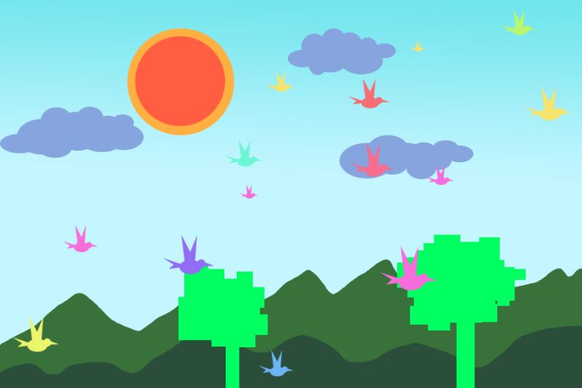

**Our goal is creating an multimedia interactive environment. According to the input of mouse, keyboard, live sound and live image , screen-base environment is reacting on these inputs. We are making a fun, playable environment with binding reality and visual world together. The environment is invoking emotion of existence and increase interactive experience .**

# Opening Scene

**There a an interactive environment with 2d colored circles full of screen. Mountain background involved enhancing movements.**

**Circles are moving randomly. Also changing the circles color randomly. Change the circles radius(5-10pixels) according to sound volume.**

# Interactive Scene One

**Moving mouse over the environment, when the mouse pressed, selected area circles are following the mouse point.**

How fast the mouse moves, how fast the audio plays. (ongoing)

If mouse stops moving, audio remain the original speed.(ongoing)

**If mouse double clicks or press any key , activate a camera.**

**Web Camera will catch live image. It analyzes the color of pixels of capture images.**

**Analyzing process will ignore black, greyscale and white color. Program will be Only catching red-like color pixels. The red-like pixels will be shown on the canvas by drawing 5 by 5 pixels red rectangles one the canvas according to where the red-like pixels located from capture images. The most red pixel are shown by 10*10 pixels circle. Output redX, redY to function followRed();**

**Program will be also calculate the brightest point on the live image. And outputting targetX, targetY to function followBright();**

Ongoing process

In future, camera will capture multiple brightness top 10 point which is installed on human body . while human is making gesture, machine will follow. On the canvas , will be simplified skull-ton system who represents movement that camera captures( circle + line).

While doing gestures, there are options that offering the additional function such as snapshot of motion (stop motion animation) or artistic expression of live images.

**Assignment divided**

**Sanjaya has done opening scene and sound interactive part.**

**Xiaojie has done camera interactive part**

**Sanjaya and Xiaojie both have done the jointing part which is putting two parts of coding together.**